**Part 2:**

**Business Data Analysis Report**

**1: Introduction**

* In this section, the paper gives a general description of the dataset used and lists the aims and objectives of the analysis.  
   **Overview of the Dataset**  
    
  The dataset this analysis is based on is called OnlineRetail.xlsx. It is the central store of data including the transactional data from the online store of a company. The store provides insights into customers’ purchasing behavior and product preferences. undefined  
    
  • InvoiceNo  
  • StockCode  
  • Description  
  • Quantity  
  • InvoiceDate  
  • UnitPrice  
  • CustomerID  
  • Country  
    
  Integration of these attributes makes it the most readily accessible source of data for the conduct of market basket dataset analysis, as well as extraction of actionable business insights for the organization. Through data observation and thorough data analysis of the transactional data contained in this dataset, the objective is to identify relationships, patterns, and trends that will culminate in action plans that will, among other things, lead to better customer experience, improve inventory, and ultimately, sales will increase for the online retail store.

**Purpose of the Analysis**

The purpose of this paper is to apply market basket analysis with association rule mining methods. The market basket analysis is one of the most basic data mining methods to determine the relationship between products that are purchased frequently together by customers. Through the meticulous examination of transactional data, our aim is twofold: Through the meticulous examination of transactional data, our aim is twofold:

1. Discover Trends in Customers’ Purchasing Behavior
2. Build up Actionable Insights for Business Decision-Making from Data.

This research aims to provide businesses with the knowledge and forecast needed to make the right choices, increase operational efficiency, and ultimately satisfy customers more and more. In the meantime, the objective is to achieve better revenue returns and a sustainable business model in a competitive environment.

**2: Application (Business Insights, Comments, Observations, and Recommendations)**

This Section provides a deep look into the analysis process that includes data preprocessing, the Apriori algorithm application, parameter adjustment, reading the results, and gaining business insights.

**Data Preprocessing**

Data preprocessing is critical in terms of the data screening for quality and integrity prior to analysis. The following steps were taken:  
Removing Spaces: The leading and trailing spaces were removed from Description column so as to be on the same measure.  
Handling Missing Values: Rows with absentness InvoiceNo were removed from the dataset.  
Excluding Credit Transactions: Credits credits (invoice no 'C') were excluded from the data set as they did not contribute to the analysis.  
  
These steps of data cleaning and data preprocessing their makes the dataset usable for the purpose of market basket analysis.  
  
**Applying the Apriori Algorithm**  
The study utilized the Apriori algorithm to detect the most common itemsets from the transaction data with a minimum support level of 7%. This approach gave rise to the generation of association rules that are the main crux of uncovering customers purchasing behavior patterns.

**Adjusting Parameters**In this section, the research delved into different values of parameters such as support, confidence, and lift to exemplify how these systemize the association rules. The main focus is to modify the support threshold according to which the itemsets and association rules are considered to be noteworthy. Using the adjusted threshold support mechanism, the end goal was to distinguish the occurrence of such patterns.

Customer purchase behavior gives useful information to help businesses in their decision-making process. This was the process that allowed identifying the relevant associations between items, and regulate product cross-sells to enrich our idea about customers’ interests.

**Interpreting Results**

Through this analysis, the association rules found in the dataset, stand to shed light on the relationship between data items within the system. Indicators like the support, confidence, and lift were used to evaluate the generated association rules.

Support characterizes the rate by which items occur in the dataset. From the analysis, it was found that the general range of support values for association rules was around zero. The low value shows that the most frequent rules are associated with itemsets that have relatively low frequency.However, some rules displayed higher support values, suggesting associations with more frequent itemsets. This distribution underscores the varying levels of popularity and occurrence of different itemsets within the dataset, as shown below.

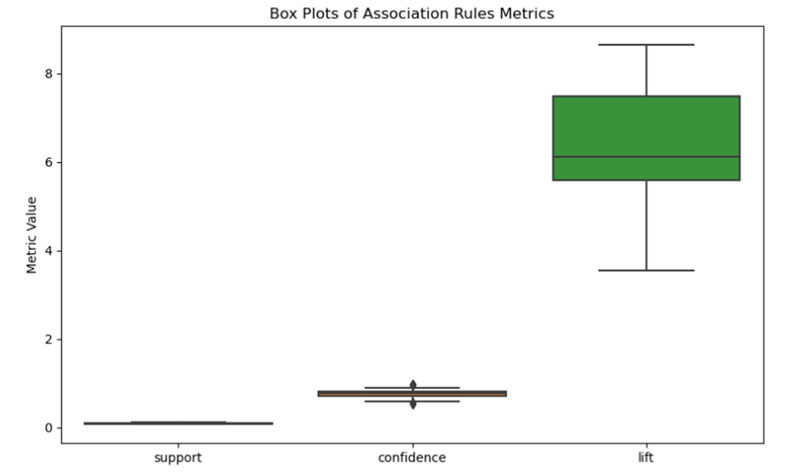

Confidence, as the buying confidence that results from buying the consequent given the antecedent, was also another important metric to examine. Reporting indicated that most of the association rules were observed with a confidence value of one, which pointed out that the consequents would certainly follow the antecedents. This reveals the extent and strength of the links between the antecedent and consequent, the latter of which represents the more stable patterns in consumer buying habits.  
  
Moreover, lift which is the degree to which items are counting each other more frequently, decorated the correlation between items. The high majority (more than 50%) of the association rules display a lift of values clustered around six which means the antecedent and consequent items are found in the shop shelf, six times more often than if they were not correlated as shown in the lift heatmap below.

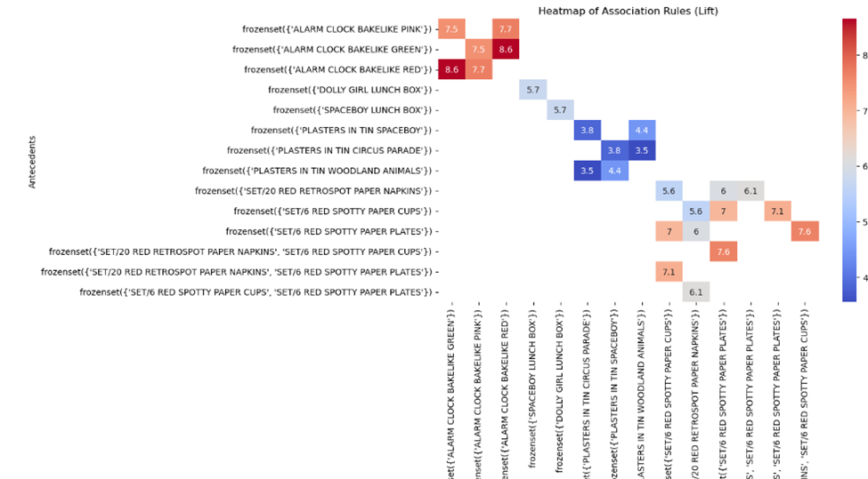

**Providing Business Insights**

These patterns translate into applicable messages that companies can use to take immediate action. Examples include product bundling, cross-selling, and customized marketing campaigns using customer preferences.

1. Product Bundling: Identify complementary items to create package offerings, boosting transaction value.
2. Cross-Selling: Offer suggestions for customers’ related products that can make further sales.
3. Personalized Marketing: Customize campaigns in such a way that customers are picked and it generates engagement and leads to the loyalty of the customers.

**3: Conclusion**

In conclusion, conducted research has given us a unique insight into the client’s behavior and preferences, these being verified by support, trust, and uplift factors. The findings are full of great advice on the way to business, including how to use packaged products, leveraging cross-selling, and custom designing marketing campaigns to learn more about the customers' needs. Furthermore, with the growing data analysis, we will be able to stay in the lead since regular analysis of this information will help further secure an edge while using advanced analytics as a strategy to remain relevant in the market. The data is clearly ideal for evidence-based decision-making processes. As a result, we will be equipped to serve our clients in a much better way than before and will still be competitive in the market.